Week 5 soil recap

Lecture 1

Water is a polar molecule. Mineral surfaces tend to be negatively charged and the positive side of water molecules stick to mineral surfaces. Two key properties of water are adhesion and cohesion; Adhesion is the attraction of water molecules for solid surfaces and cohesion is the attraction of water molecules to eachother. Cohesion is the force that allows for surface tension. Capillarity is the propensity of water to defy gravity through the forces of adhesion + cohesion and rise through pores.

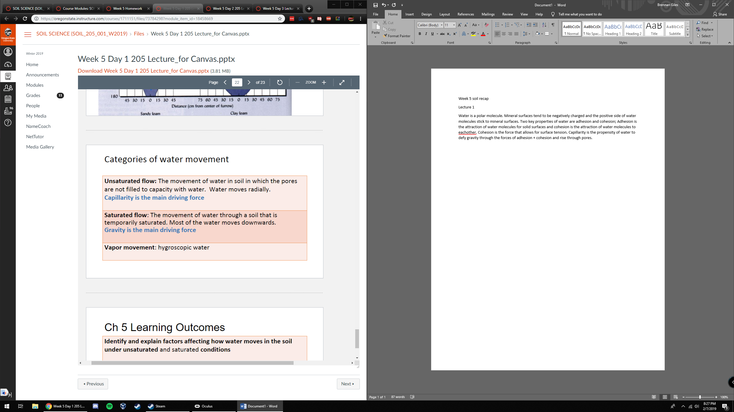

Lecture 2

Water travels fast, but not far, in coarse soils. Water travels far, but slowly, in fine soils. Water potential is the tendency of water to move from one area to another. High water potential means free water held at low tension, and low water potential is sticky water held at high tension. Water moves from high water to low potential. Low potential is the top of the straw where it is drier; water wants to get sucked up the straw to get that sticky film on minerals at the top.

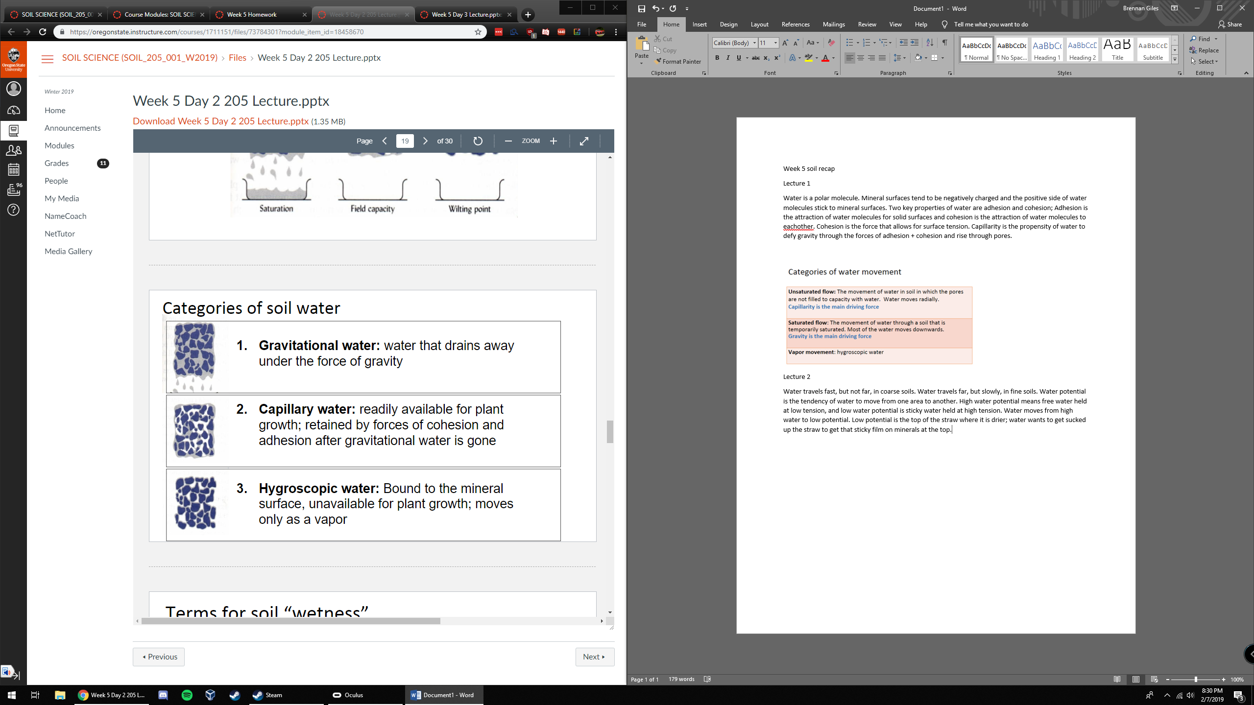

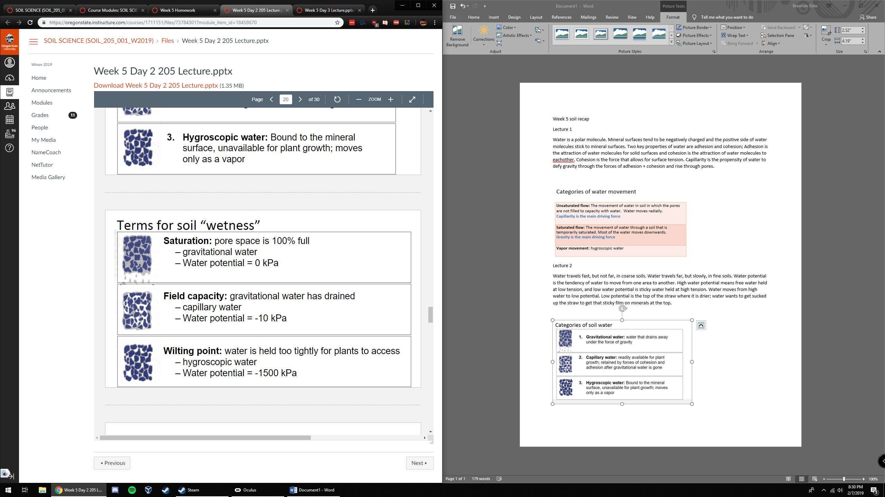

Water potentials; field capacity is at -10 kpa and wilting point is at -1500 kpa.

Lecture 3

Infiltration is the process by which water enters soil pores.

I = Q/(A\*t)

Q=volume of water

A= area of soil surface

T = time

If rate of rainfall is greater than rate of infiltration we get runoff, which causes soil erosion and pollution of surface waters with sediment, nutrients, and chemicals. No filtration of runoff water.